**Jupyter notebook Installation**

Following is the step by step procedure to install Jupyter notebook

Step1 : Please visit https://www.anaconda.com/distribution/#download-section

Step2: Download Pyhthon 3.7 version for windows installer

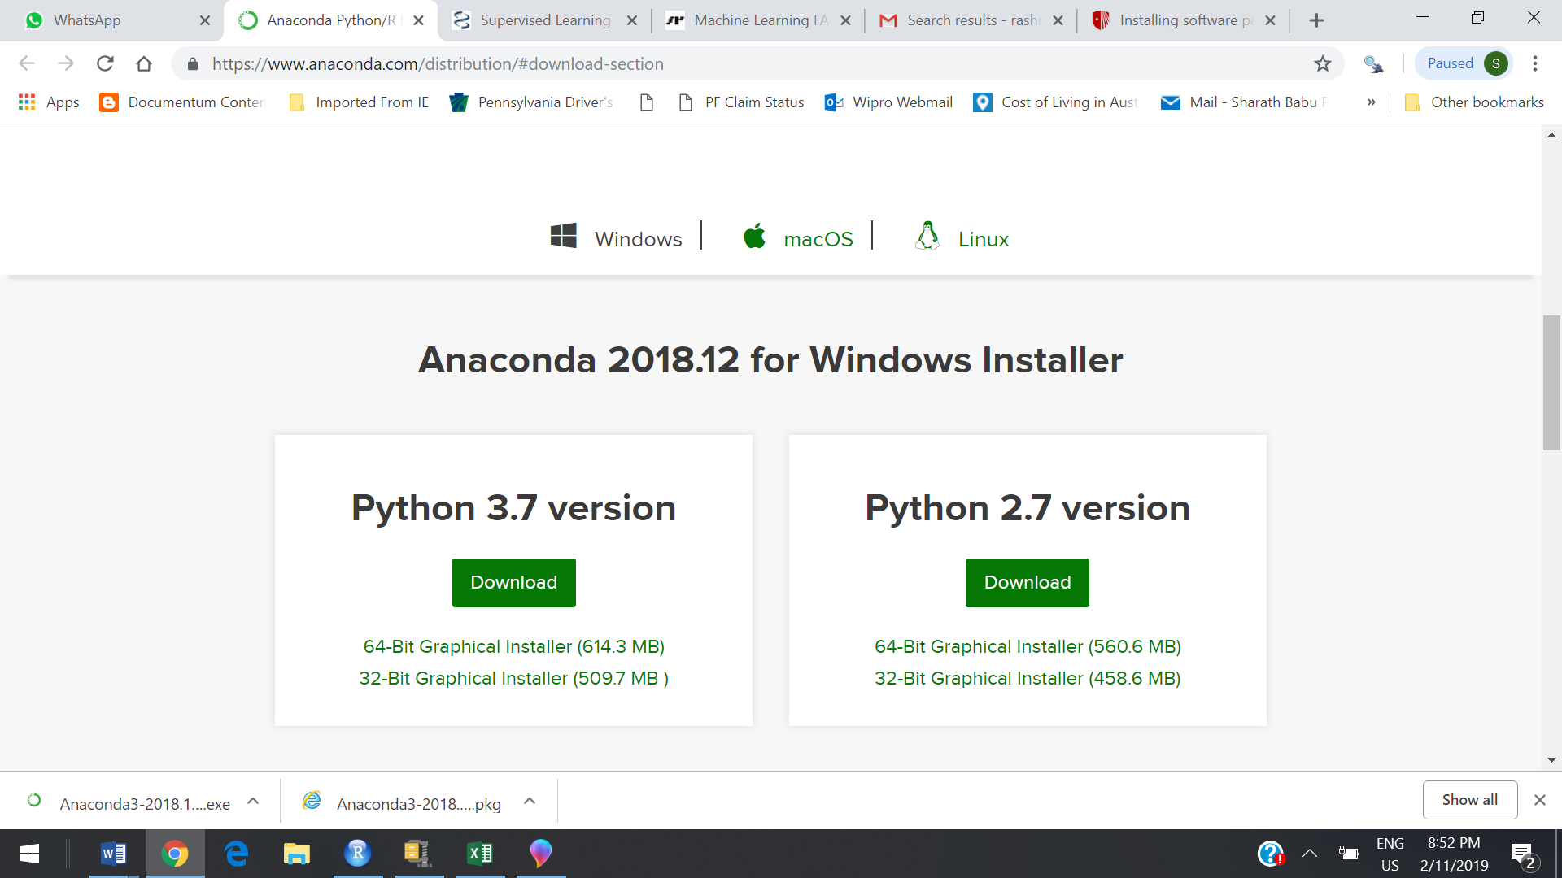

Step3: Click Run….

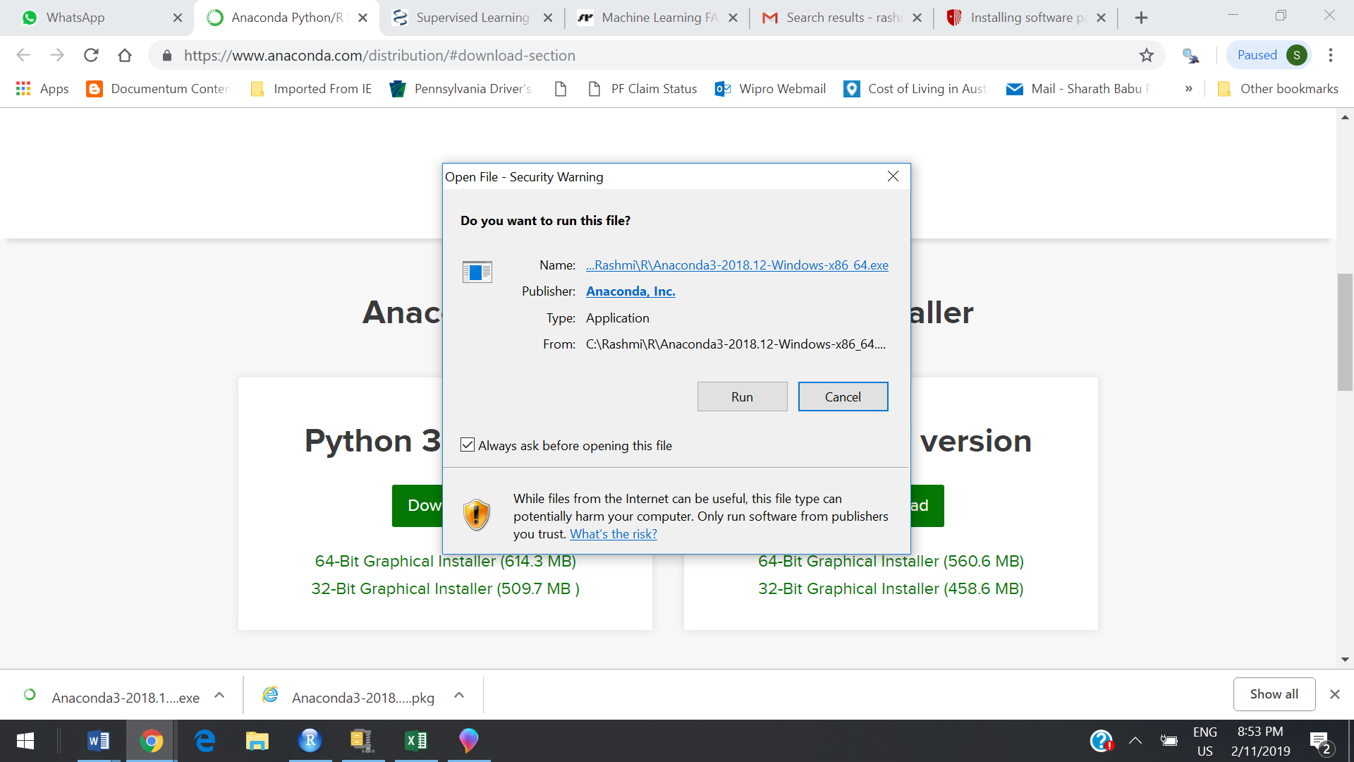

Step4 : Do Next

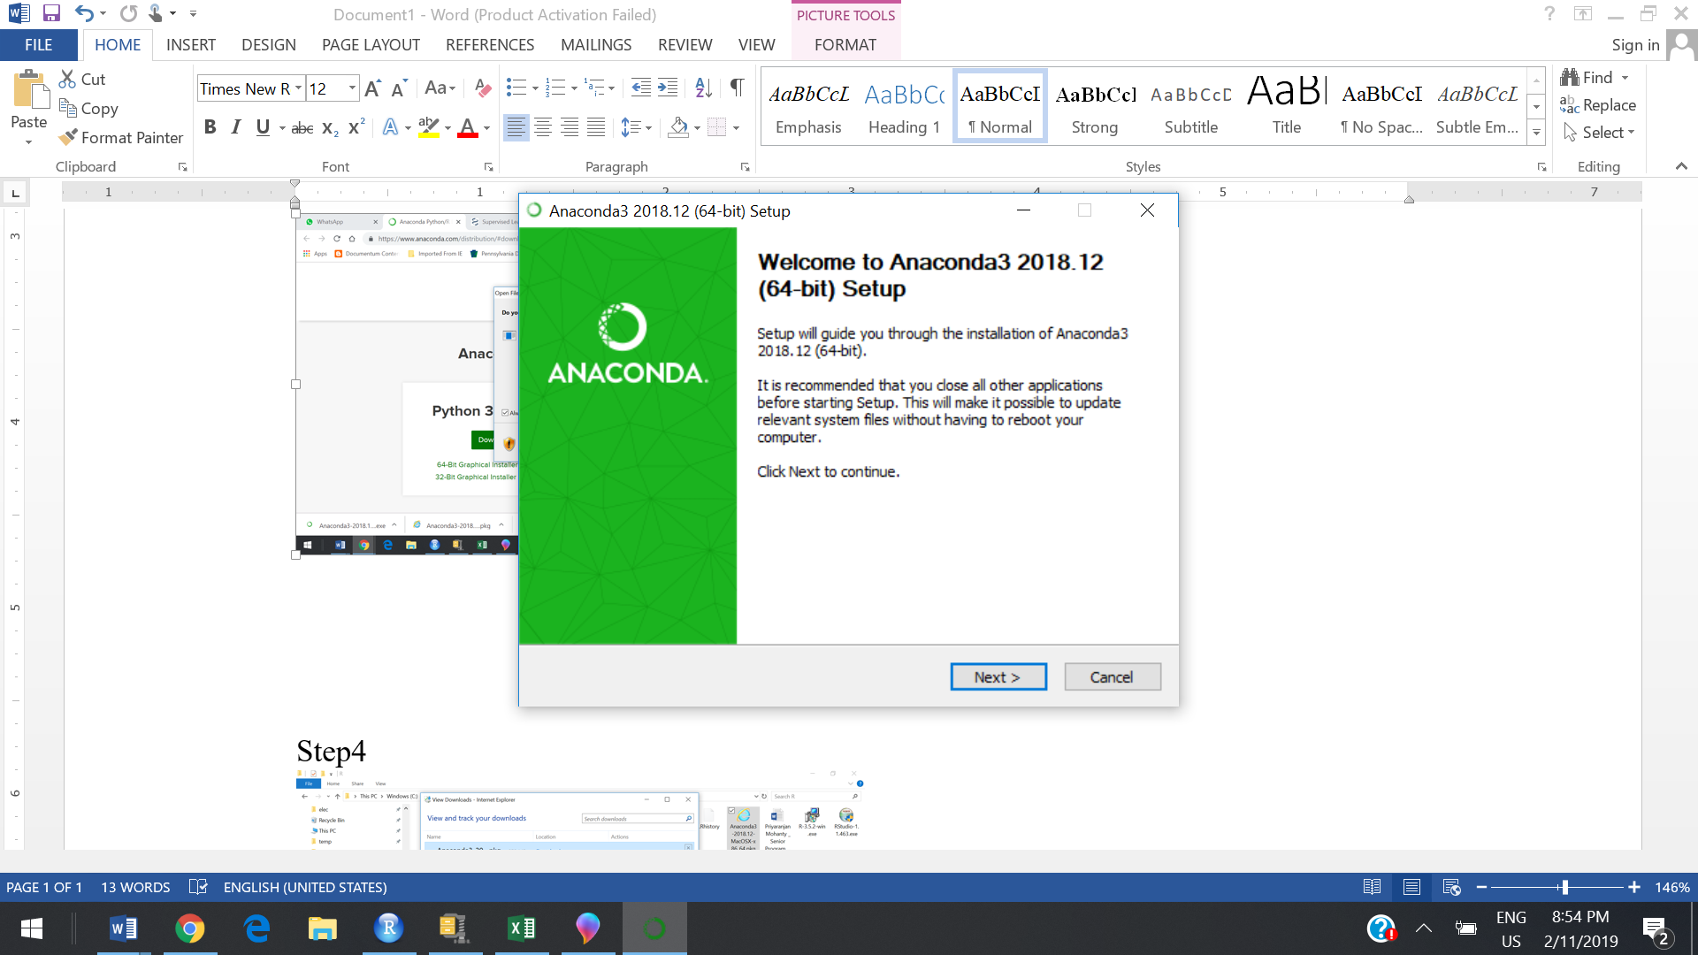

Step5: Click I Agree…………

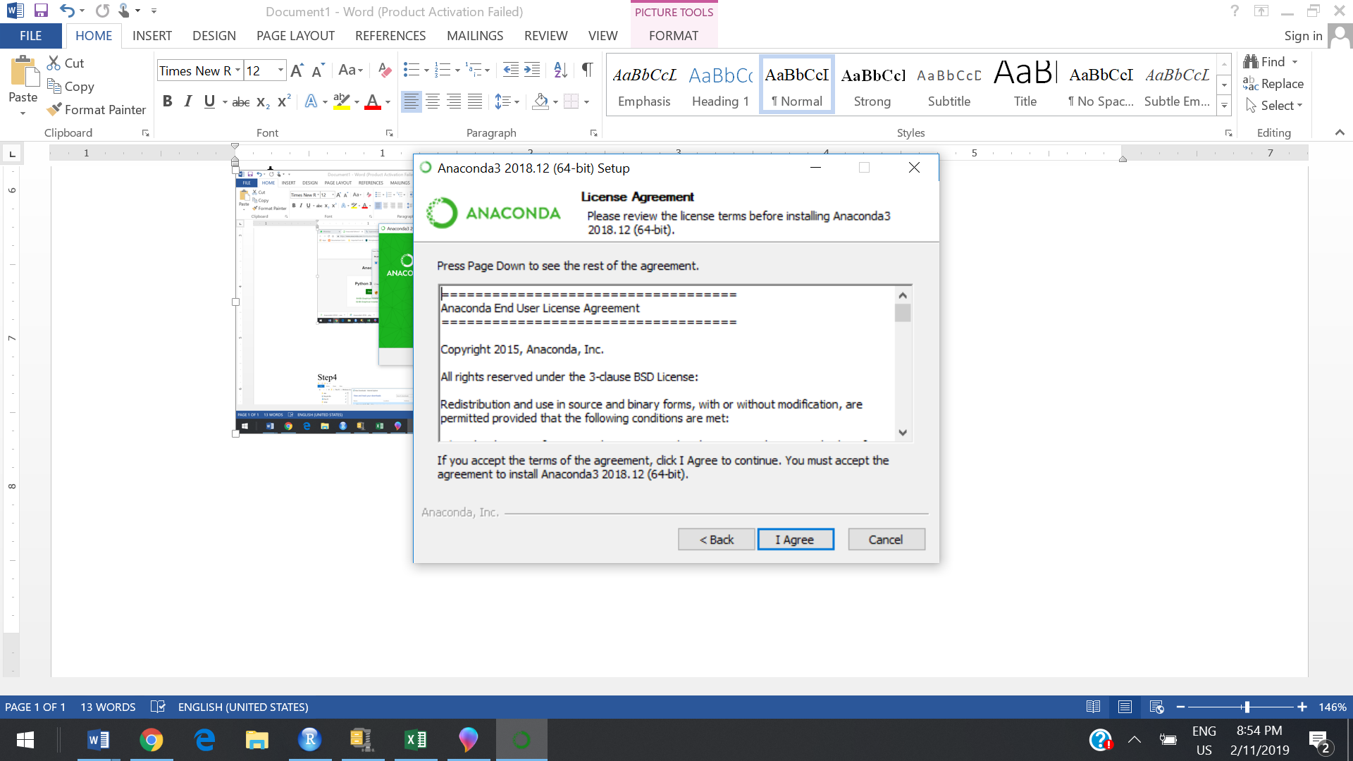

Step6 :Click Next….

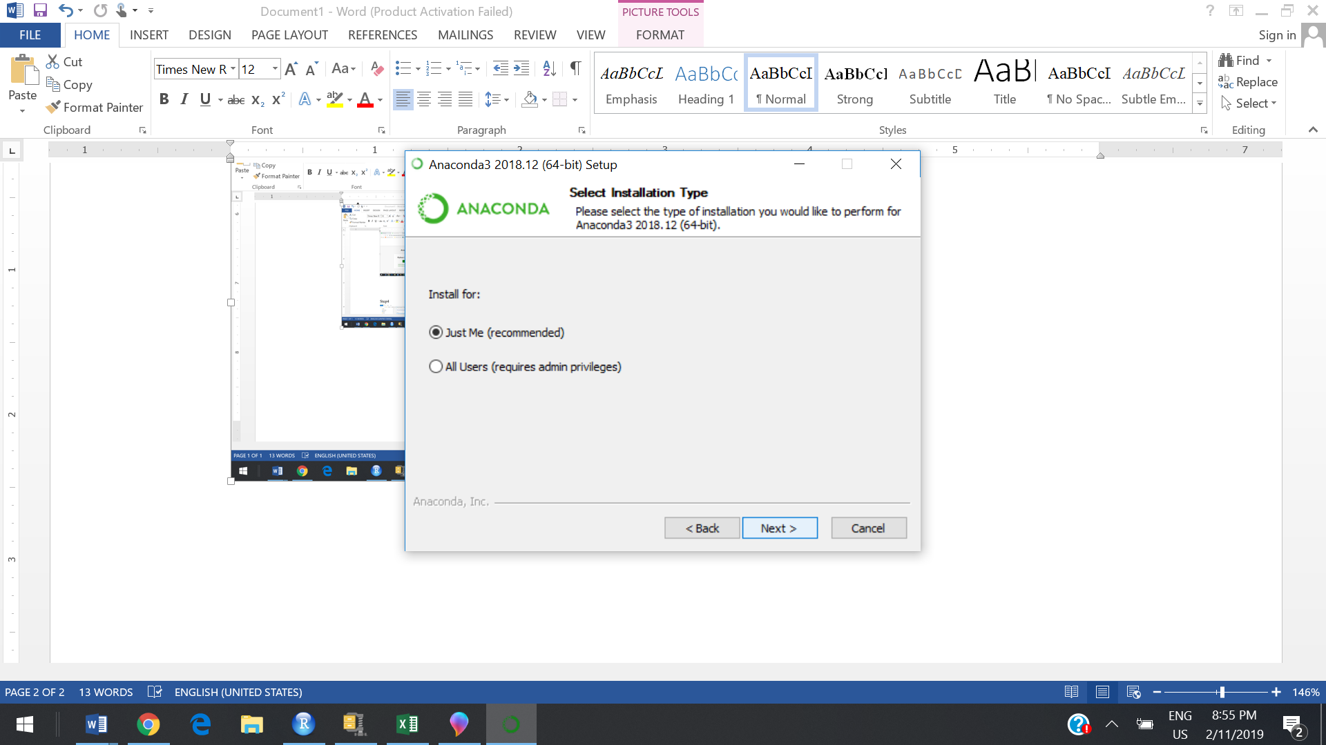

Step7: Click Next

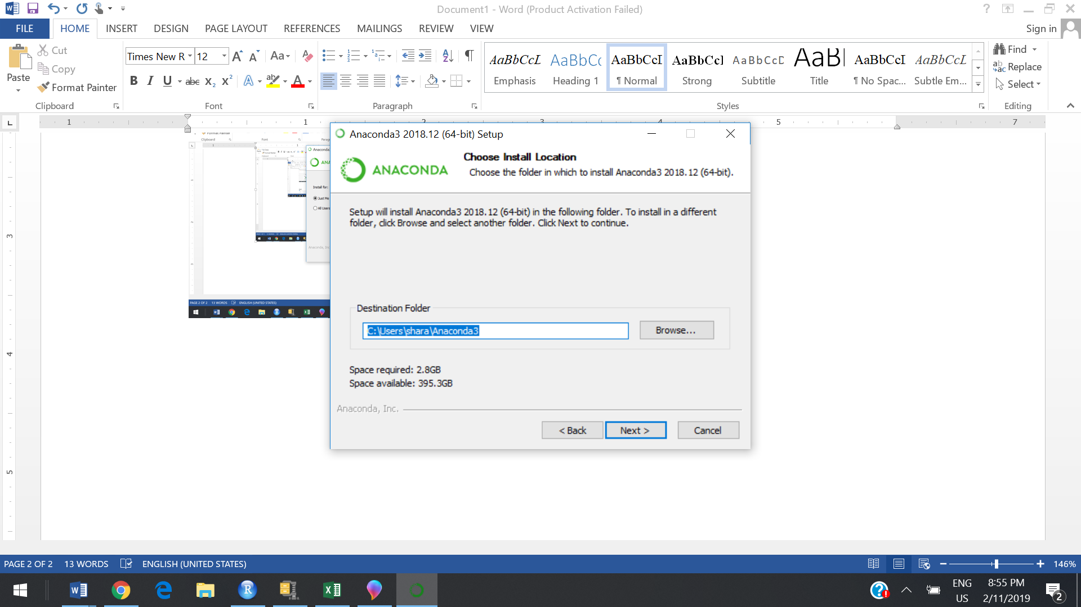

Step8 : Click Install…..

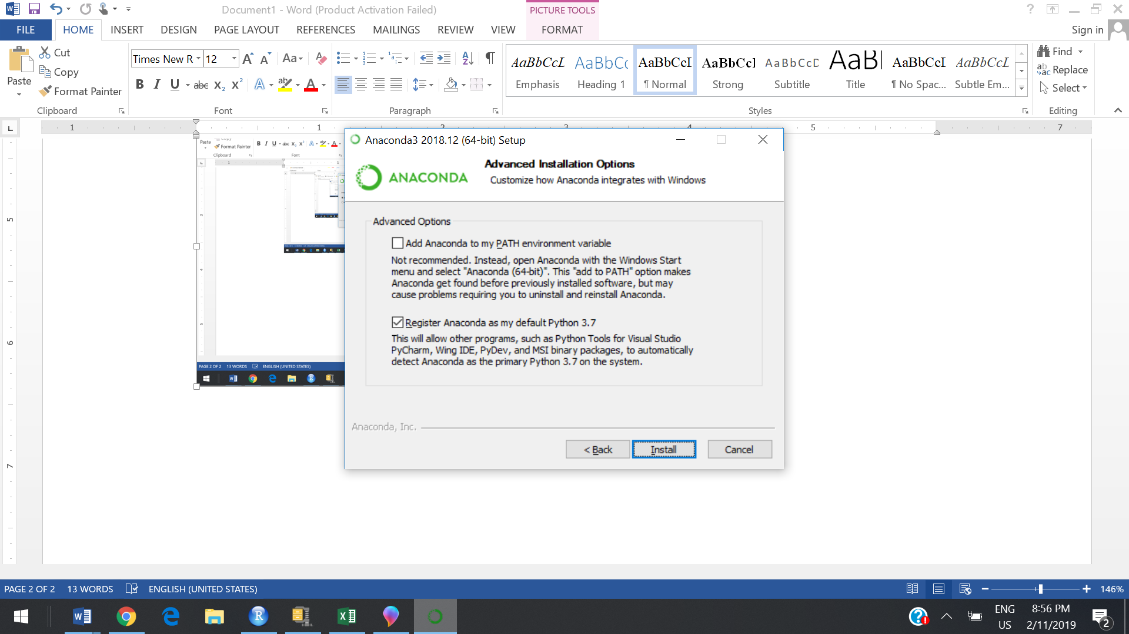

Step9: Let it install…..wait till it gets install completely

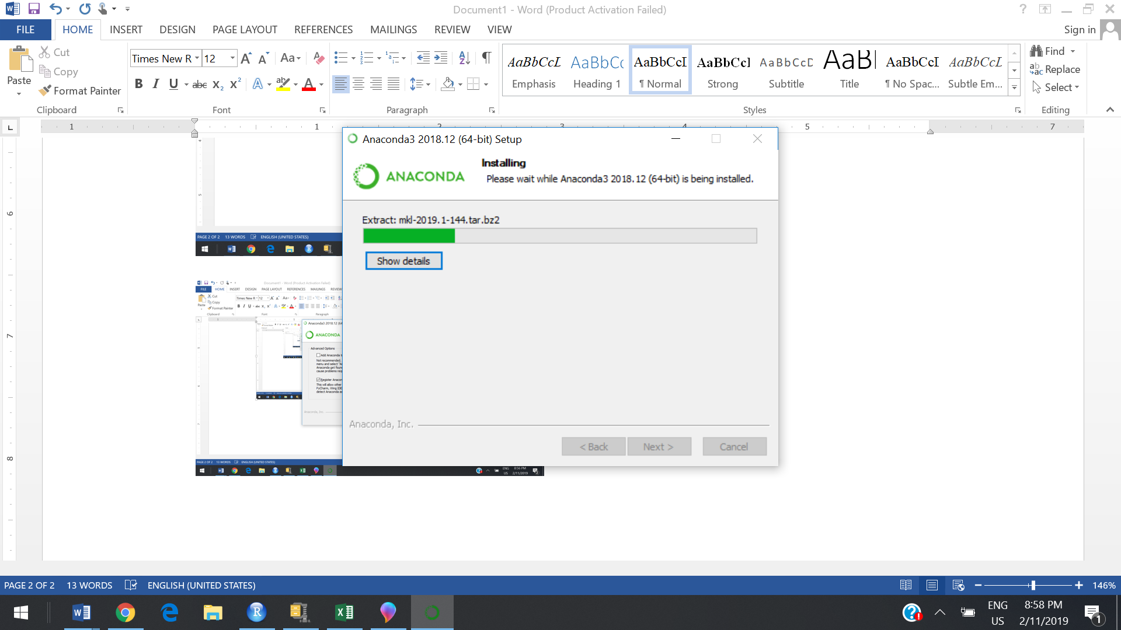

Step10 :After above step. You can see Anaconda Navigator as shown below

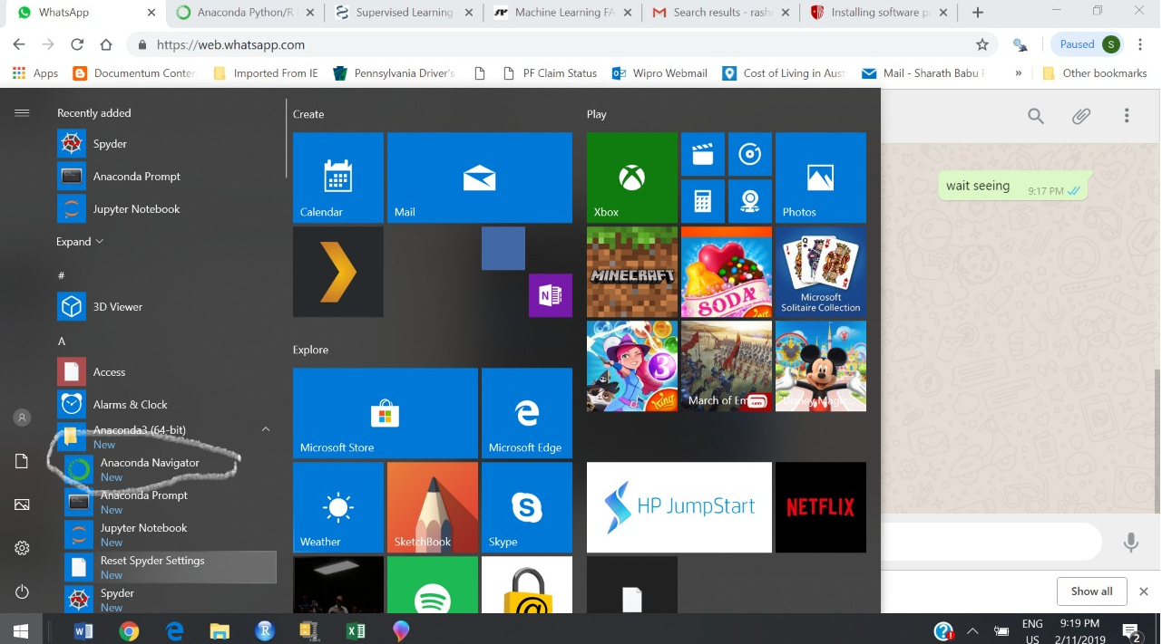

Step11: Please select Environments

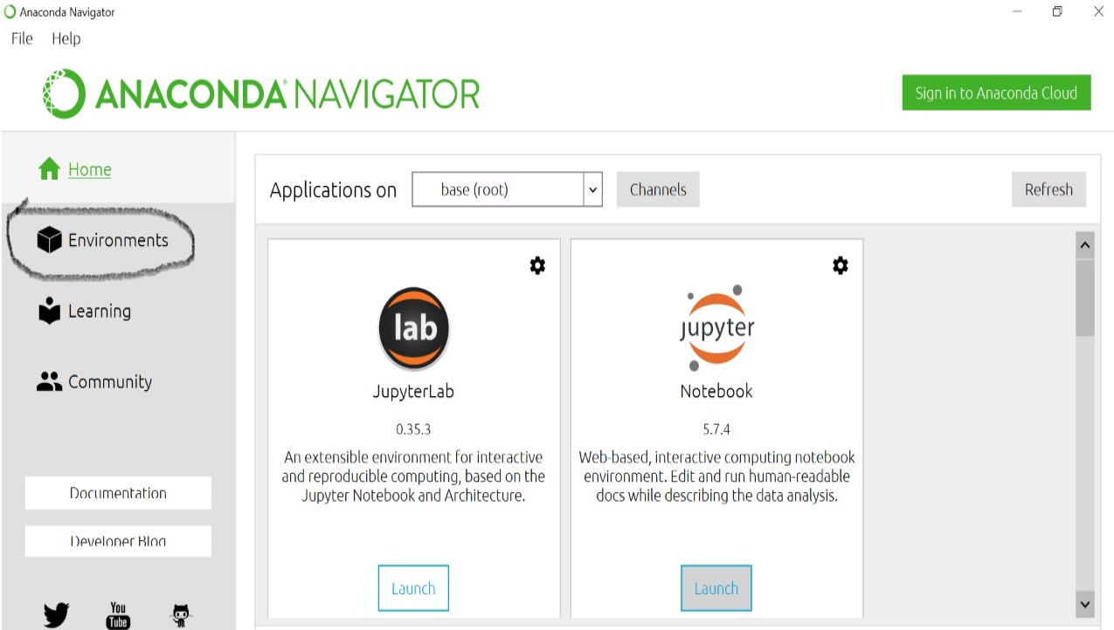

Step12: Click Create…..

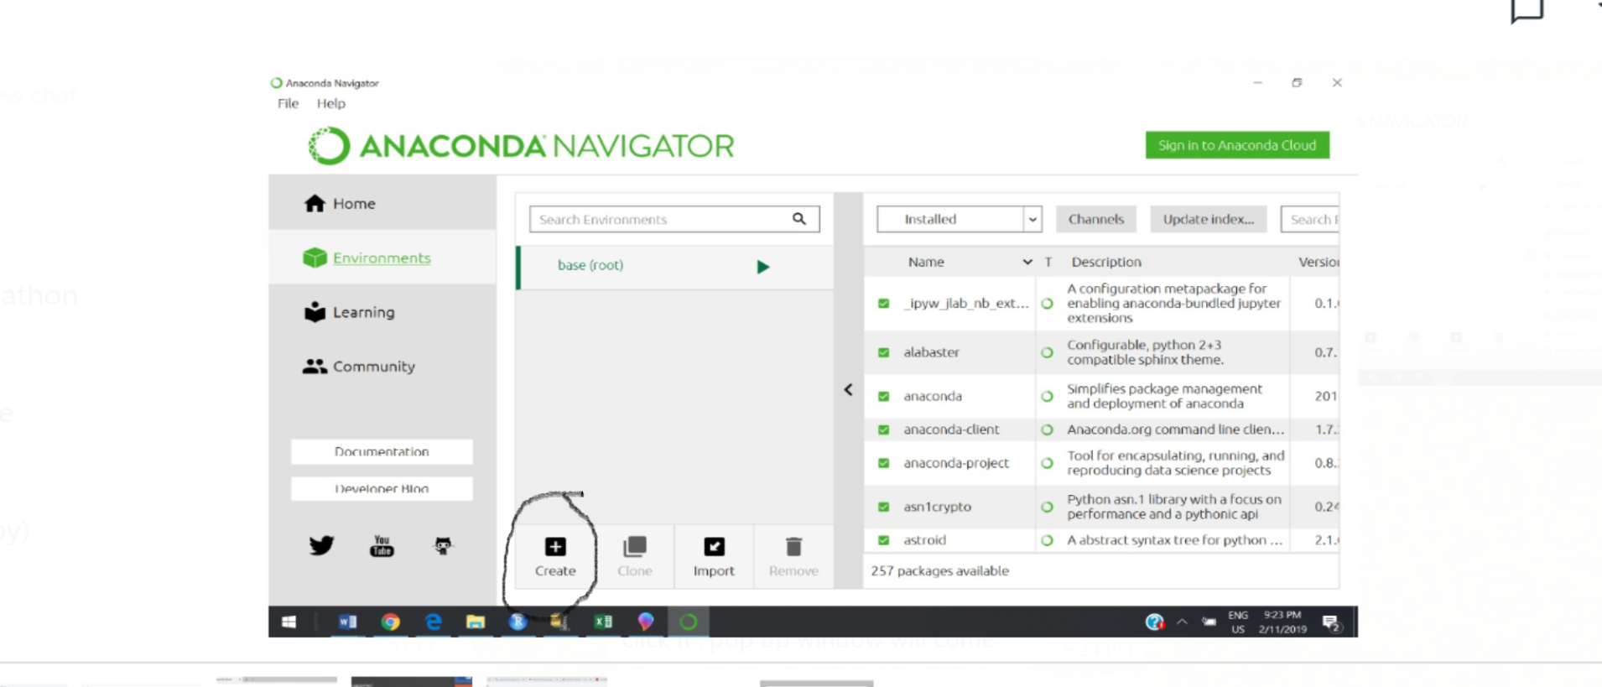

Step13: Give some name ...in the Name box , select R checkbox and from the drop down infront of R , select R ..and then press create

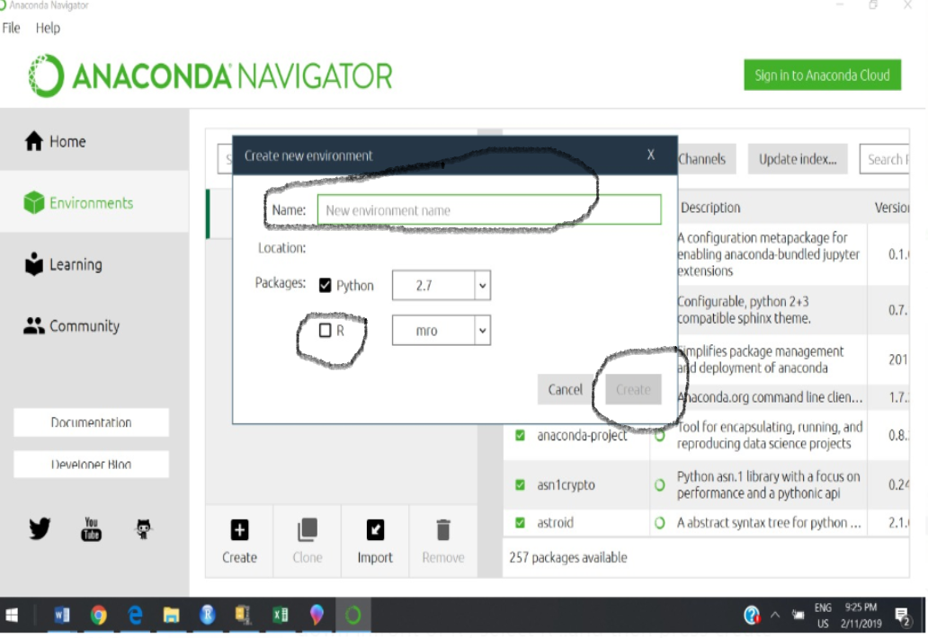

Step14 : Let it install…………….

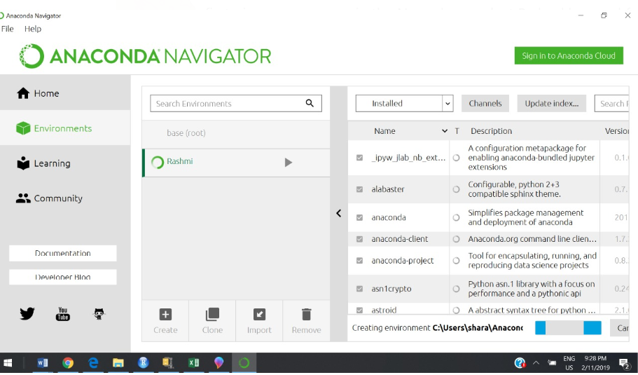

Step15 : Now you can see your profile under the Anaconda folder. As highlighted…Just open it

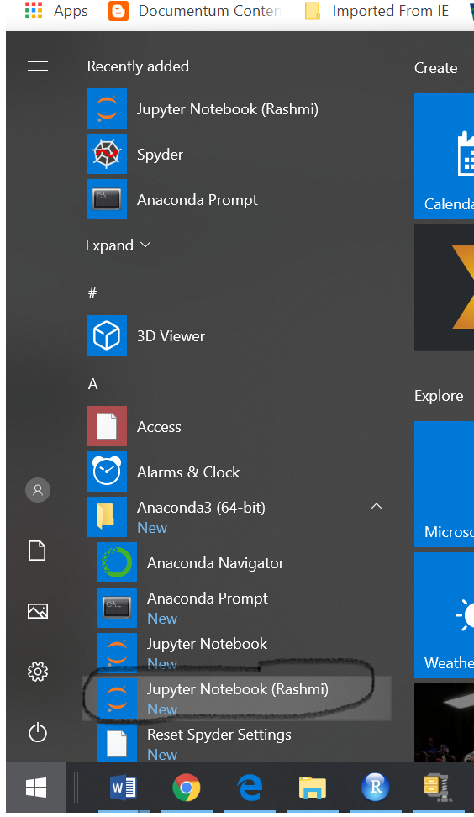

Step16 : Please see the below and click ok

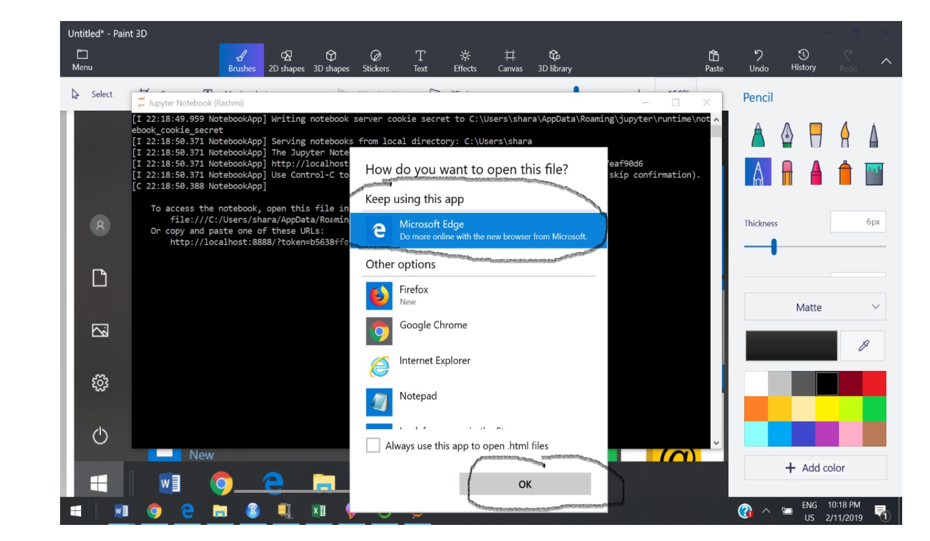

Step17 : See 'New' button at the top right it is drop down both python & R in drop down click R. new webpage will open

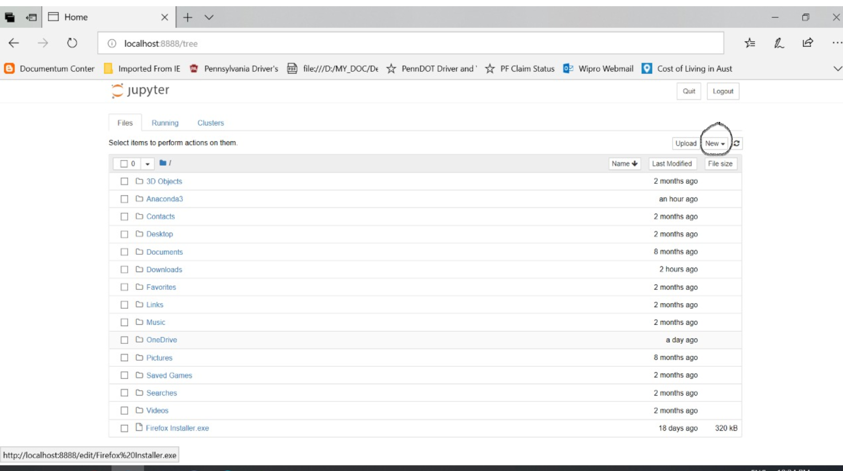

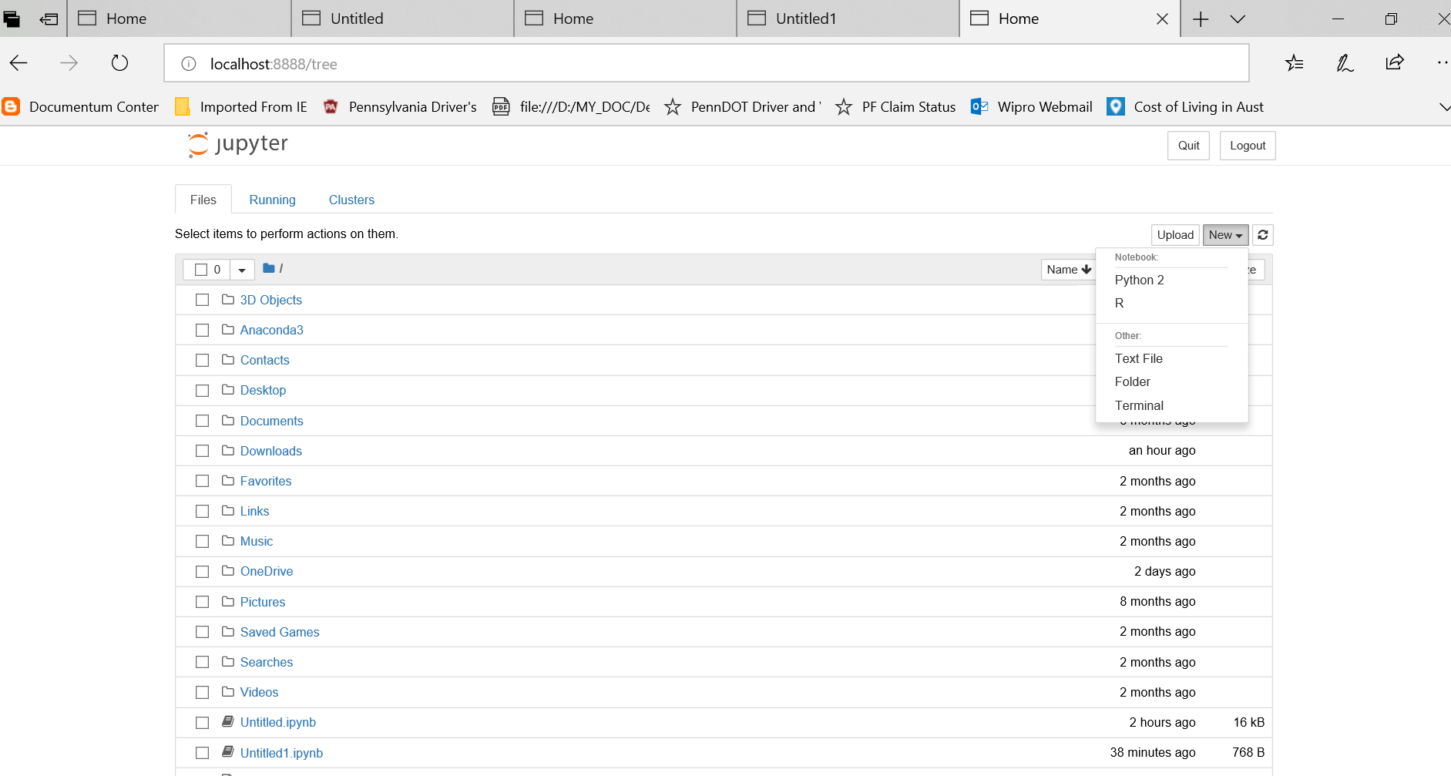

Step18: Here you go……….we have Jupyter notebook

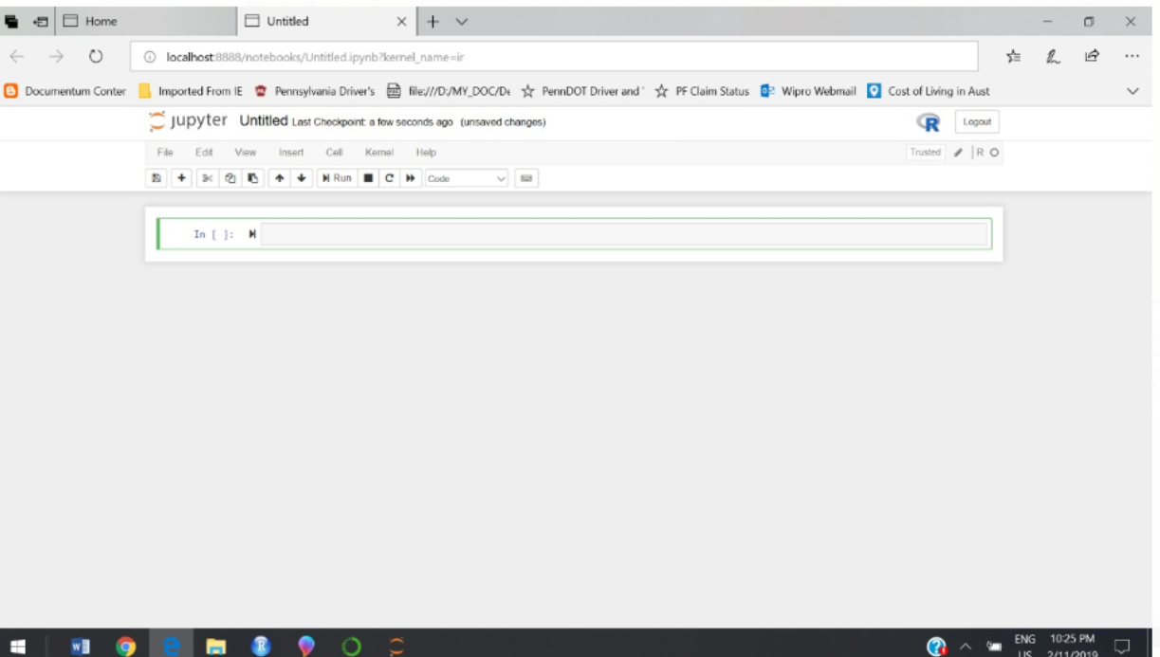

Step19: Write some code as shown below….use **shift & enter** to go to next line of code…….

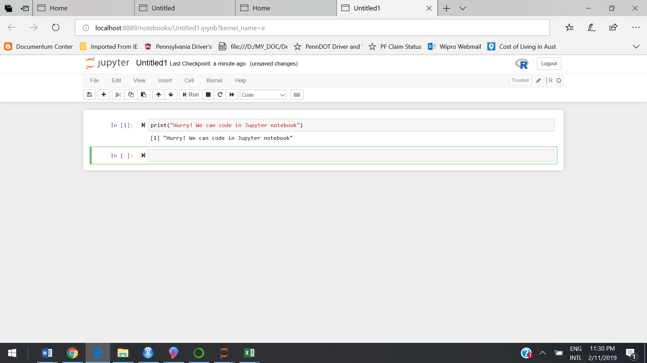

Happy Learning…………………